STARTING SCHOOL
A GUIDE FOR PARENTS
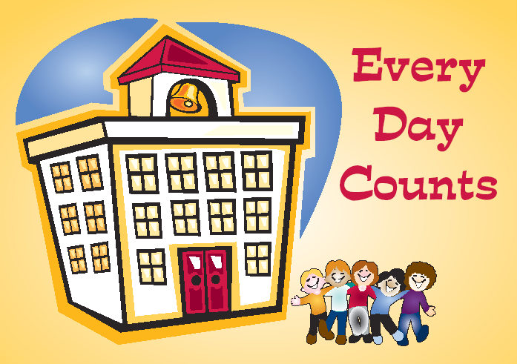
Welcome!

Here at St Mary’s and St Benedict’s we have a happy, friendly team!

We aim to provide a warm and welcoming environment for our children and families when they start school.

We would like to emphasise the important role you play in your child’s education. In order to feel confident and secure your child needs to see the relationship between home and school. Good communication between families and school helps to ensure a smooth transition and also enables the teacher to learn about each child from the adult that knows them best.

We look forward to working with you to build a strong partnership based on mutual understanding and respect.

Starting School

Starting school can be an exhausting business!

Don’t be surprised if your children come home feeling tired and not wanting to talk about their day.

Give them a meal, a bath, a cuddle and a story, before getting them off to bed early.

The School

School address Brownedge Lane

Bamber Bridge

Lancashire

PR5 6TA

Telephone number 01772 336650

School website www.smsb.lancs.sch.uk

Headteacher Daniel Ballard

Deputy Headteacher Janette Mercer

Chair of Governors Sue Haworth

Helpful Information

School day Start 8:45

Finish 3:15

Training days See school website for INSET closures

School holidays See school website for holiday list

Admissions Policy School follows the Local Authority Admissions Policy

Religious Worship Roman Catholic

Attendance

Attending school every day, starting in nursery and continuing in reception classes, will help give your child the best possible start in life.

Going to school every day means:

♦ making friends

♦ having lots of fun

♦ building lasting relationships

♦ time to play

♦ taking part in exciting activities

You can help us to help your child by encouraging regular school attendance.

Your child’s education is very important; attendance habits established in the foundation years of education can affect their entire school life.

♦ If your child is too ill to attend school or is absent for any other reason, please contact the school on the first day of absence

♦ If you are in any doubt as to whether to send your child to school please contact the school as soon as possible for advice

Setting good attendance patterns early on will also help your child later on. Although it seems a long way off at the moment, future employers want to recruit people who are reliable. Children who have a poor school attendance record may have less chance of getting a good job.

What happens if a child does not attend school regularly?

By law, all children of compulsory school age (between 5 and 16) must get a suitable full-time education. As a parent you are responsible for making sure this happens and if you fail to ensure a child of compulsory school age attends school regularly, legal action may be taken by the Local Authority.

Leave during Term Time

PLEASE THINK CAREFULLY BEFORE TAKING YOUR CHILD OUT OF SCHOOL DURING TERM TIME

- In law you must ask for permission for your children to miss school, well in advance of the planned absence

- Parents can request a leave of absence but, by law, this can only be authorised if the circumstances are exceptional

- Parents who take a child of compulsory school age out of school without permission from the school may be issued with a penalty notice

TO HELP YOUR CHILD DO WELL IN SCHOOL, YOU SHOULD:

- Arrange family holidays/leave of absence to coincide with school holidays wherever possible

- Avoid times when there are important examinations or tests (check with school)

- Always ask the school well in advance for permission

- Be aware of the potential impact on your child’s education

A Shared Philosophy

The School provides a secure, caring and stimulating learning environment which will enable children to acquire the skills, knowledge and understanding necessary to become confident, independent learners.

In a relaxed, happy atmosphere, children can develop confidence, self-esteem and respect for others, whilst reaching their own full potential emotionally, intellectually, socially, physically and spiritually.

At St Mary’s and St Benedict’s we aim to provide challenging learning experiences for both indoors and outdoors, acknowledging the value and importance of quality outdoor provision for young children.

Our aims

♦ To create a safe, caring and stimulating learning environment

♦ To establish high expectations at an early stage by helping the pupils to develop an inquiring mind and a positive attitude towards learning

♦ To encourage each pupil to become confident, independent, responsible and sociable

♦ To work in partnership with parents recognising the important influence of the family

Settling in at St Mary’s and St Benedict’s

The first half term is our settling in time. The first day can be a difficult time, especially for parents, particularly if you are dealing with your first child starting school.
We will communicate with you frequently during these early days so that we can ensure the settling in period goes as smoothly as possible.

What can you do to help?

10 things we would like you to teach your child before they start school

- To dress and undress

- To remove their coats, gloves and hats and hang them up

- To put shoes on and take them off

4. To recognise and look after their belongings

- To use the toilet on their own

- To wash and dry their hands

- To use a knife and fork

- To tidy up

- To share and co-operate with other children

- To enjoy the new experience of school!

Working in partnership with parents/carers

St Mary’s and St Benedict’s works in partnership with families. We recognise that you have already taught your child a great deal and you are still the expert where he/she is concerned.

At school we will build on what your child has already learned. We want you to feel involved in your child’s education.

Parents will be kept informed of any relevant events and information by a variety of means.

If you would like to know more about something or have any queries or concerns do feel free to approach the staff.

Play

The natural way for young children to learn is through play.

Here we use play to:-

- provide an opportunity to develop language

- provide opportunities and motivation to practice basic skills

- help develop self confidence

- help children to learn to share

- encourage thinking and decision making

- nourish curiosity

- develop concentration

- stimulate interest

- provide a secure basis for further learning

Daily Routines

Each class will have its own routine that is designed around the age and needs of the class.
Routine provides reassurance and stability to the children and helps them settle and learn.
We always advise parents to try and create a morning routine that works for you and your child so that they come to school feeling settled.

Questions and Answers

What should my child wear?
We are proud of our school uniform. The children look smart and take great pride in their appearance.
Please see our school website for a detailed breakdown of uniform and where it can be purchased.

What type of shoes are appropriate?
We ask that children wear black shoes for school and black pumps for PE.

What can I do about jewellery?
We advise that children do not wear any jewellery. If children have pierced ears, they need to wear safety ear rings to avoid accidents.

Can my children bring toys?
We ask that children don’t bring toys. We know that toys can have a sentimental value and it can cause a great deal of upset if a toy is damaged or lost.

What about bringing and collecting my child?
The school gates open at 8:30am and you are welcome to escort your child into the playground. After school, the gates open at 3:05 and you are welcome to wait on the playground outside your child’s classroom.

Can my child bring sweets?
We allow children to bring snacks such as fruit to eat at playtime but we ask that they don’t bring sweets and chocolates. Occasionally, sweets might be shared by the class teacher on special occasions such as birthdays.

Will my child be doing homework?
Children will receive a small amount of homework each week. We ask that all children read every night. For more information, please check your child’s webpage.

What should I do if my child is absent from school?
Please contact the office at the earliest opportunity to report a child’s absence.

Can I stay and work with my child?
We invite parents into school occasionally but we ask that parents do not stay with their children during lessons.

What should my child wear for PE?
We have a school PE kit which consists of shorts, pumps and a white t-shirt. Please see the website for more information.

What does my child need for outside work time?
This is weather dependant. On cold days children need to wrap up warm. On hot days they will need protection from the sun.

Can my child bring a packed lunch to school?
All children from Reception to Year Two are entitled to a free school dinner. However, you can provide a packed lunch should you wish to do so.

At St Mary’s and St Benedict’s we are always happy to chat with our parents and share any information you might need.

Please feel free to contact us if you need any further information.

