St. Mary’s and St. Benedict’s RC Primary School
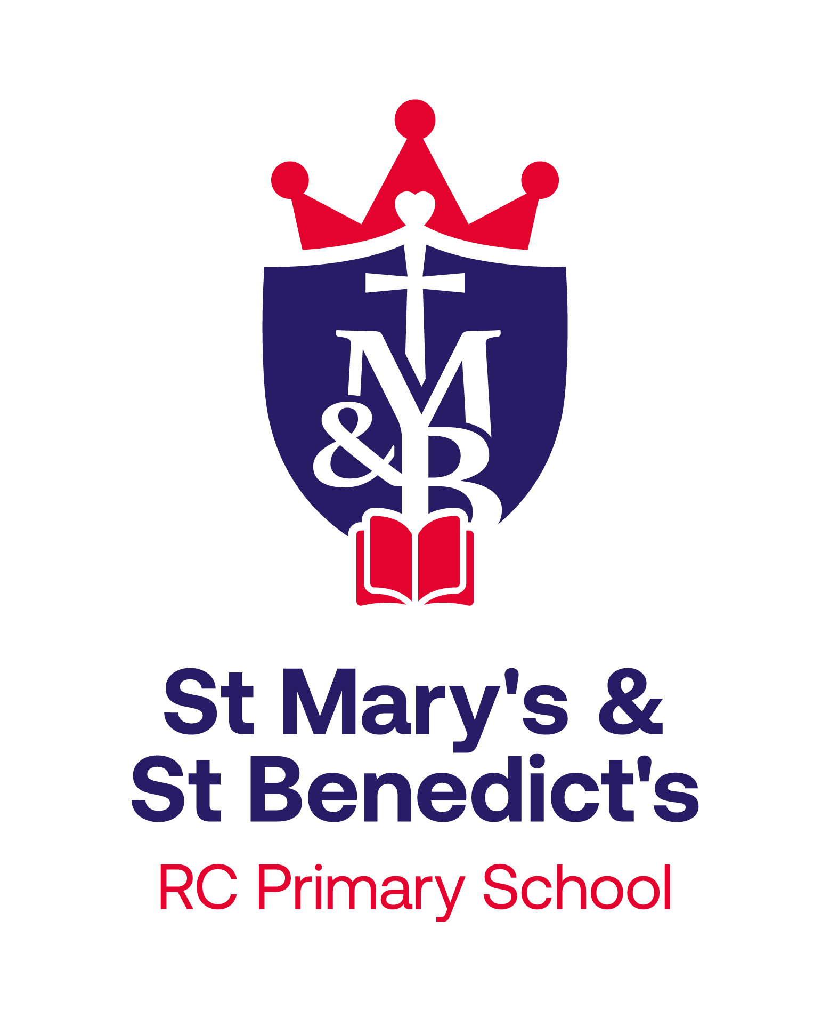

Provision for Able, Gifted and Talented

‘With Jesus, we learn as a joyful family and flourish to be the
best that we can be.’

Introduction
At St. Mary’s and St. Benedict’s Primary School, we are committed to developing the ‘whole pupil’ and providing the best possible provision for pupils of all abilities. We plan our teaching and learning so that each child can be appropriately challenged and ‘be the best that they can be’, in line with our school mission statement:

‘With Jesus, we learn as a joyful family and flourish to be the best that we can be.’

We want our pupils to strive to achieve their full potential and we are committed to achieving high quality learning and equality of opportunity. We aim to provide a supportive and caring environment in which the talents of each pupil will be valued and nurtured.

We will measure success by both academic performance and an increase in the confidence and independence of our learners.

The purpose of this policy is to help ensure that we recognise and support the needs of those children in our school who have been identified as ‘Able, gifted and talented’.

Definitions
The DCSF (Department for Children, Schools and Families) defines able, gifted and talented learners as:
Those children and young people with one or more abilities developed to a level significantly ahead of their year group (or with potential to develop those abilities).
They can be identified in any year and amount to 7-10% of the school population.
Able learners are defined as those who have abilities in one or more subjects in the statutory school curriculum, other than art and design, music and PE. They have the capacity for, or demonstrate, high levels of performance in an academic area. This also includes children who are leaders or role models and who display outstanding leadership and/or social skills.
Gifted children are defined as those with an innate ability, who present a natural, outstanding aptitude or competence for exceptional performance.
A talented pupil is one who demonstrates high levels of achievement with a specific ability in a non-academic area, including art, music, sport or the performing arts.

In comparison with their peers, when engaged in their area of expertise, ‘able, gifted and talented’ pupils will tend to:

- Show a passion for particular subjects and seek to pursue them
- Master the rules of a domain easily and transfer their skills to new problems
- Analyse their own behaviour and hence use a greater range of learning strategies than others (self-regulation)
- Make connections between past and present learning
- Work at a level beyond that expected for their years
- Show intellectual maturity and enjoy engaging in depth with subject material
- Actively and enthusiastically engage in debate and discussion on a particular subject
- Produce original and creative responses to common problems.

Aims

At St. Mary’s and St. Benedict’s Primary School we aim to enable our able, gifted and talented pupils to achieve their full potential by:
- providing a culture of high expectations which encourage each child to achieve their maximum potential, regardless of faith, gender, race or ethnicity
- delivering a high-quality education in a welcoming, friendly and supportive environment
- planning and making provision for the needs of the individual pupil
- encouraging pupils to think for themselves, to ask questions and to contribute ideas
- offering a wide range of challenge and opportunities in the classroom and beyond
- carefully monitoring every pupil’s progress
- creating an ethos where achievement is celebrated, where individuals are valued and a life-long love of learning is fostered.

Identification
We will aim to identify the most-able pupils, wherever possible using a combination of the following:

- analysis of summative test results and formative teacher assessments including Yr1 Phonics screening, KS1 SATs, EYFS assessment data
- discussions with teachers and with parents
- information from specialist teachers, e.g. sports coaches, music teachers
- performance in sports, drama, music etc
- discussions with pupils during the year and continuous observations.
- Pupil observation

Identified pupils are added to the most-able pupil register, which is updated on our whole school assessment tool iTrack and identified on class lists and within teachers planning. Parents will be informed, when appropriate, that their child is most-able in a particular subject and the appropriate targets will be explained.

Provision
Class provision includes:

All teachers ensure that there are a variety of in class strategies to stretch and challenge the most able pupils and that these pupils have suitably challenging targets.
Strategies include;
- A variety of flexible groupings used effectively e.g. ability grouping, mixed ability, learning partners etc.
- Differentiation, which can be achieved in the classroom by; outcome, resource, task, dialogue, support, layered questioning or pace and at home with differentiated homework, amongst others.
- The development of independent learning by allowing pupils to organise their own work, to carry out tasks unaided, evaluate their work and become self-critical.

Tasks can be:
- Mastery tasks which allow pupils to apply the curriculum in more complex and in-depth, cross‐objective methods. They demonstrate how skilfully a pupil can apply their learning. Mastery is not just knowing a fact, but it is using that fact in increasingly more complex situations, often using reasoning or problem solving.
- Extension work occurs when pupils are encouraged to develop more sophisticated thinking and reasoning skills.
- Enrichment tasks consists of broadening a pupil’s education. This can consist of enabling a pupil to study aspects of the topic that there would not normally be time to study, or it can consist of adding extra subjects to the curriculum.

Provision beyond the classroom

Within the school:
- Specialist teachers, who ensure a wide range of high-quality opportunities in both music and sport within the curriculum and beyond the classroom
- Wide range of lunchtime and after school clubs
- Opportunities for performance, including at The Guild Hall (music)
- Shared celebrations of success both in and out of school in celebration assemblies.

Links with other schools:
- Enrichment and extension classes at other schools when available - Regular sporting events and tournaments e.g. High five Netball

The wider community:
- Encouraging participation in local events e.g. Art/ Music competitions
- Entering local and National competitions e.g. British Science Week competitions - Encouraging the use of parental expertise

Opportunities are always planned within the financial restraints of the school budget.

Social and emotional considerations
We recognise that the emotional needs of a most able pupil are as important as the educational needs. Pastoral care and support will be provided by the class teacher and other members of staff, through the P.S.H.E scheme, circle times and as a specific need arises.

Monitoring and Evaluating
Class teachers are accountable for the attainment and progress of pupils in their class. They will regularly monitor the progress of their pupils and are responsible for ensuring that provision, support and challenge meet the needs of their most-able learners. They review the pupils termly, following summative and formative assessments and make alterations as necessary. They liaise with parents as appropriate, on how they can support their child’s learning.

Key Stage leaders and SLT will use pupil tracking data, to identify pupils who do not make expected progress and through pupil progress meetings, evaluate the success of strategies implemented to support pupils in their learning. Most-able pupils are discussed at pupil progress review meetings. The EYFS and KS1 leader will maintain a whole school record for most-able learners and will monitor and evaluate overall provision within school.

Date of Policy: September 2022

Date Review Due: September 2023 (or sooner if appropriate)

