French
POLICY

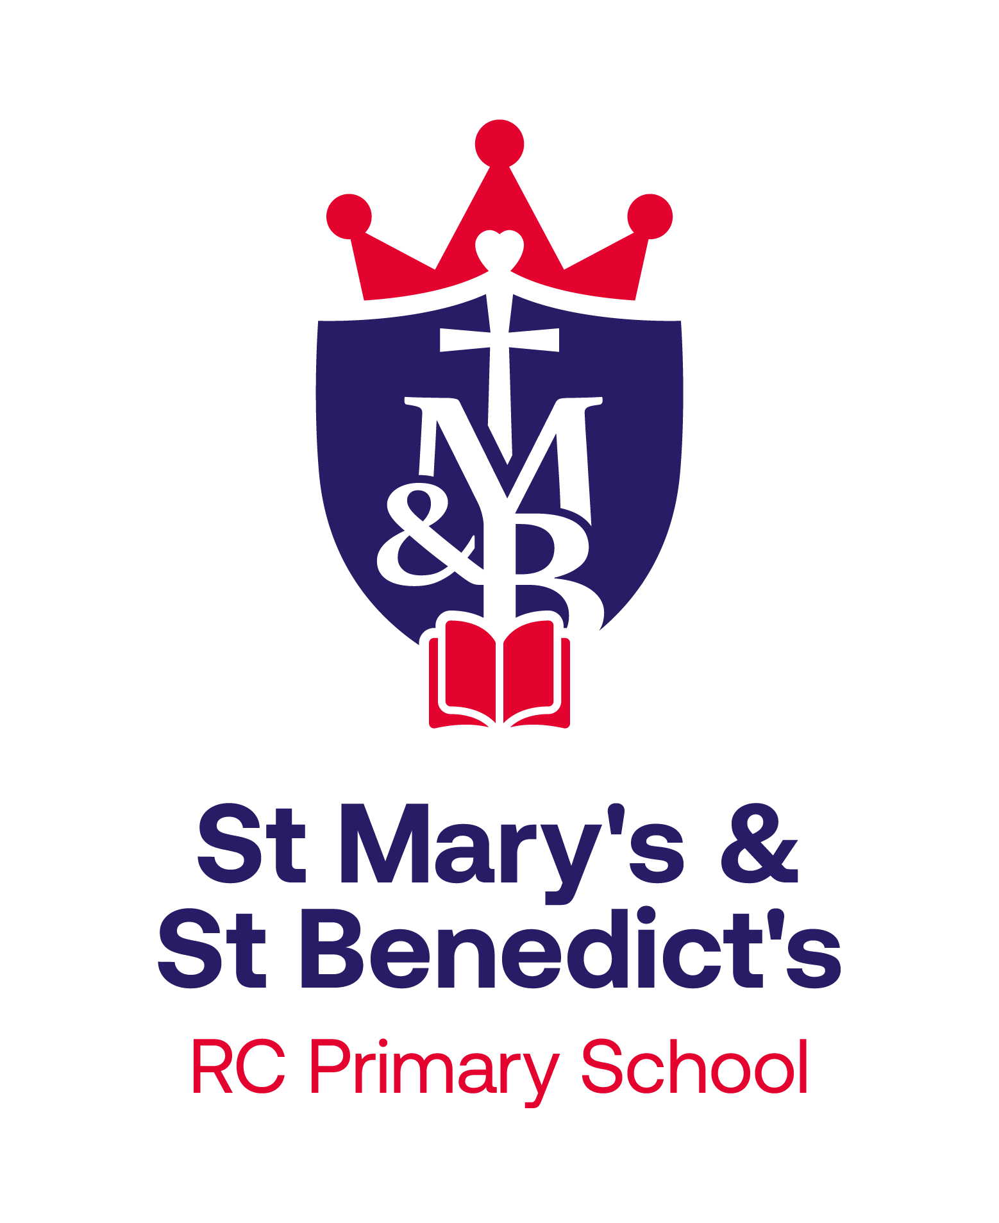

Together in God’s family, we grow in faith, knowledge & love to reach our full potential, and to become the people that we are created to be.

Policy Agreed: February 2023
Review Date: February 2025
Our School Ethos
At St. Mary’s and St. Benedict’s we aim for our curriculum to inspire pupils to be life-long learners with a sense of service to the world that they live in and the people that live in it with them.
We believe our pupils will be life-long learners if they are able to be:
- confident,
- independent,
- curious,
- open-minded,
- enthusiastic,
- observant,
- co-operative and
- resilient individuals.
In order to develop these qualities within our pupils we intend for our curriculum to provide opportunities for children to:
- Be curious and ask questions
- Evaluate and reflect
- Work collaboratively
- Apply their learning
- Solve problems whilst developing resilience
- Communicate their learning
- Challenge ideas
Vision for (MFL)French
At St. Mary’s and St. Benedict’s, our vision is that each child will receive a high-quality education in French, which will encourage pupils to develop a love of learning a foreign language, which they can continue beyond their primary years. Our vision is for pupils to appreciate the French language and French culture and develop an enthusiasm, not just for learning a new language but also about French traditions and life. We aim for children to become confident in speaking and listening to simple phrases and sentences in French, so that they are able to understand and communicate some simple ideas to others. It is also our vision that pupils in our school will leave KS2 with the necessary linguistic skills of being able to read and write some simple French phrases and sentences, giving them the basic knowledge and understanding of the French language to be able to build on in the future, ready for the next step of their learning journey- transitioning into KS3 and flourishing as life-long linguists.
French Intent
At St. Mary’s and St. Benedict’s Primary School, our high-quality French curriculum aims to fulfil the requirements of the National Curriculum in an exciting, inclusive and challenging way. We follow the National Curriculum objectives for Modern Foreign Languages and have adapted the curriculum to suit our needs as a school. We have high expectations for our children and we ensure our planning is against Age Related Expectations for each year group. We ensure tasks are appropriately differentiated or adapted to meet the individual needs of our children.
The teaching of French should equip children with the confidence and linguistic skills to be able to understand, speak, read and write some basic words and phrases. Also knowledge, understanding and appreciation of French culture and traditions are promoted throughout the curriculum.
This year, we intend to hold a French day, as part of the European Day of languages. This will inspire children’s curiosity about France and the language in Key Stage 1 and give pupils in Key Stage 2 an opportunity to ‘show case’ their language skills, knowledge and learning so far. It is also our intent to strengthen links with the MFL department at the high school, so that, not only can our pupils can benefit from the expertise their linguistics have to offer but also to help build on our pupils growing confidence in learning a foreign language.

French Implementation
We teach French in Key Stage 2 using the Language Angels scheme of work, which we have adapted to suit our needs. Each class has a weekly 40 minute French lesson, within their year group. As our school, we deliver the French curriculum on a linear, progressive pathway, building on the children’s increasing confidence in and knowledge of the French language, as they progress through each year group. We ensure all children have complete coverage of the National Curriculum and have access to the same experiences and that there are opportunities for children of all abilities to develop their linguistic skills and knowledge in each topic and we build planned progression into the scheme of work so that the children are increasingly challenged as they move up through the school. Send children and children with additional requirements will be given support to ensure that they are able to access the curriculum. Initially, at the beginning of Y3, children’s learning in French is mainly through speaking and listening, songs, games etc. This will progress to reading and recording simple written words and phrases in their French books, as they become more familiar with basic vocabulary. As children progress, aspects of grammar will be introduced and then built on, according to the children’s abilities. When possible, through powerpoints , video and audio clips, children will be given opportunities to listen to native French speakers.
At present, French is only covered in Key Stage 2 but it is our aim to eventually teach French in EYFS and Key Stage 1. This will ensure that we can keep building on our pupil’s confidence and skills in learning a language as they move through school and that our Y6 pupils have a firm foundation in French ready for their transition to high school.
development.
Assessment for Learning is embedded in French lessons and children are active in reviewing the successes in their work. Children are encouraged to build their confidence, especially in spoken French and are encouraged to ‘have a go’ at pronunciation of new vocabulary. Areas for development are on-going, as the children’s language journey progresses and children are encouraged to assess their own individual progress and confidence as they seek to improve their work.

French Impact
At St. Mary’s and St. Benedict’s we recognise that quality first teaching should minimise the need for intervention strategies. Any pupils falling behind in French are given more tailored tasks and support is given to improve their attainment. More-able children are identified, and suitable learning challenges provided. Teachers make thoughtful and effective provision for the varying levels of language ability in their classes.
Work is assessed in line with the learning objectives within the National Curriculum framework for languages. Learning objectives covered are also tracked through the use of Language Angels, where topics are linked to NC objectives. On-going teacher assessment of children’s speaking, listening, reading and writing in French are part of weekly language lessons. Book looks and discussions with the children also help to monitor the progress the children are making.
End of unit assessments are carried out through the Language Angels scheme. These assess the four areas of learning in MFL- speaking, listening, reading and writing. Marking is in line with the school’s Feedback and Marking Policy.
On-going teacher assessment and the end of unit assessments help to give an overall picture of where the children are on their language journey and helps to inform future planning and learning.
Specific Nature of French
The National Curriculum in Languages should focus on enabling pupils to make substantial progress in one language. The teaching should provide an appropriate balance of spoken and written language and should lay the foundations for further foreign language teaching at key stage 3. It should enable pupils to understand and communicate ideas, facts and feelings in speech and writing, focused on familiar and routine matters, using their knowledge of phonology, grammatical structures and vocabulary. The overarching aim for French in the national curriculum is to promote high standards of language and literacy by equipping pupils with a strong command of the spoken and written language, and to develop their love of learning a language, which they will hopefully take with them into key stage 3.
The national curriculum for languages aims to ensure that all pupils:
♣ understand and respond to spoken and written language from a variety of authentic sources
♣ speak with increasing confidence, fluency and spontaneity, finding ways of communicating what they want to say, including through discussion and asking questions, and continually improving the accuracy of their pronunciation and intonation
♣ can write at varying length, for different purposes and audiences, using the variety of grammatical structures that they have learnt
♣ discover and develop an appreciation of a range of writing in the language studied.

Sequencing with French

The Language curriculum at St. Mary’s and St. Benedict’s allows for progression of the skills of speaking, listening, reading and writing. The three pillars of language- phonics, grammar and vocabulary are also interwoven throughout the units covered. We use the Language Angels scheme, where the units are sequenced into early language, intermediate and progressive units. A scheme of work, using the units from Language Angels has been designed to ensure full coverage of all the NC objectives and also progression in the children’s learning.

Assessment within French

Assessment for Learning is embedded in French lessons and children are active in reviewing the successes in their work and identifying, with support from their teacher, target areas for development to ensure a continuous and individualised approach to improving their work.

Work is assessed in line with the NC objectives and is tracked using the Language Angels scheme of work. Assessments, which cover speaking, listening, reading and writing are carried out at the end of each topic. Marking is in line with the school’s Feedback and Marking Policy.
Children’s progress in French is reported to parents in their child’s end of year report and can be discussed at Parents’ Evenings.

Inclusion within French
Provision is made for children with a range of SEND that can be grouped into four broad categories of need, as detailed below:

1. Communication and Interaction

Children and young people in this category have speech, language and communication needs (SLCN) which make it difficult to communicate with others. This may be because they have difficulty saying what they want to, understanding what is being said to them or they do not understand or use social rules of communication.

Children and young people with ASD, including Asperger’s Syndrome and Autism, who are likely to have particular difficulties with social interaction may belong to this category.
2. Cognition and learning
Support for learning difficulties may be required when children and young people learn at a slower pace than their peers, even with appropriate differentiation.
Specific learning difficulties (SpLD), affect one or more specific aspects of learning. This encompasses a range of conditions such as dyslexia, dyscalculia and dyspraxia.
3. Social, emotional and mental health difficulties
Children and young people may experience a wide range of social and emotional difficulties which manifest themselves in many ways. These may include becoming withdrawn or isolated, as well as displaying challenging, disruptive or disturbing behaviour.
Other children and young people may have disorders such as attention deficit disorder, attention deficit hyperactive disorder or attachment disorder.
4. Sensory and/or physical needs
Some children and young people require special educational provision because they have a disability which prevents or hinders them from making use of the educational facilities generally provided. These difficulties can be age related and may fluctuate over time.

As a school, St Mary’s & St Benedict’s RC Primary School is committed to ensuring that all children get access to the full curriculum and we will provide suitable amendments to provision to allow this to happen.
At the bottom of this webpage: https://www.smsb.lancs.sch.uk/send/ there is a comprehensive list of subjects and the SEND adaptations that are suggested for each area. Class staff are required to consider these documents to best meet the needs of pupils with identified needs.
English as an Additional Language (EAL)
At St Mary’s & St Benedict’s, we believe that:
• EAL children learn to speak, read and write in another language through immersion in a broad, rich curriculum
• EAL learners make the best progress within a whole school context, where children are educated with their peers.
• Bilingualism is viewed as a positive and life-enriching asset.
In French lessons, EAL children are often supported by other more confident pupils, who speak their home language. Where little or no English is spoken, these children can translate French vocabulary and explain tasks in their home language. Technology is also used to help translate French to their home language, where necessary.
Able, Gifted and Talented (AGT) pupils

At St Mary’s & St Benedict’s, we understand that all children require support and challenge in their learning in order to make progress and reach their potential. Subject leaders work with teachers to identify and support these children through our teaching and learning activities, our more able (MA) pupils are given a wide variety of challenges and experiences in their learning of French which develops their resilience, inspires them and deepens their understanding of the tasks.

They are encouraged to develop their abilities to ask questions, explain and reason, persevere, communicate their thoughts and take risks in their learning. We strive to provide creative means to increase their independence and curiosity, leading to an ever-increasing love of learning.

