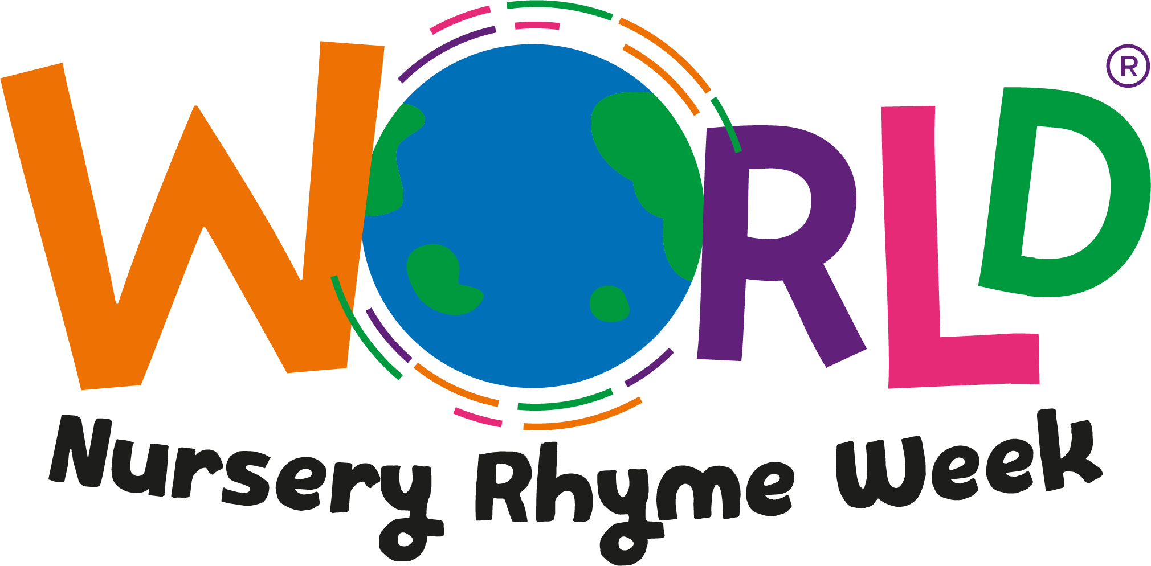

11th – 15 th November 2024.

Dear Parents,

World Nursery Rhyme Week is fast approaching, and we are delighted to confirm we will be taking part. The initiative, launched in 2013, promotes the importance of nursery rhymes in early childhood development and education with a particular focus on how nursery rhymes boost early language and literacy skills.

We have a number of activities planned throughout the week based on a variety of Nursery Rhymes. Singing nursery rhymes is a wonderful activity you can also enjoy doing together at home. You can access all of the free resources at home by registering at www.worldnurseryrhymeweek.com

We can’t wait to celebrate a wonderful week of rhyming with your children at St Mary’s and St Benedict’s RC Primary School

Best wishes,

Mrs Burgess

